**The Signs**

[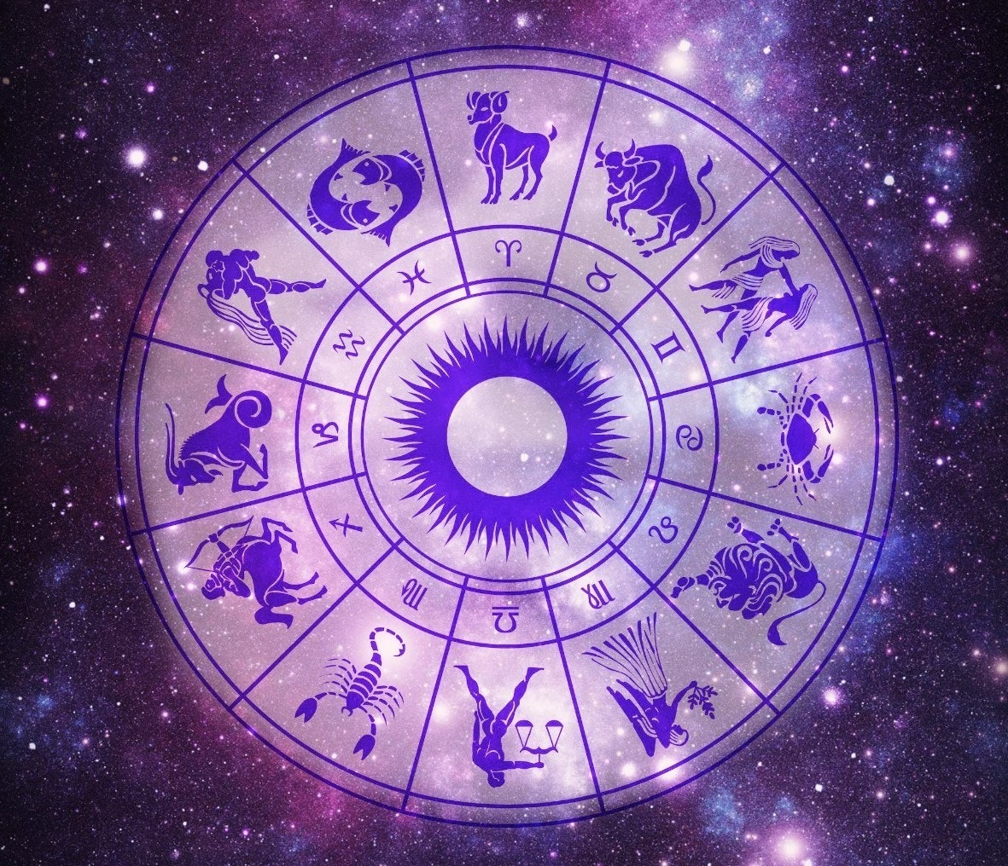](https://media1-production-mightynetworks.imgix.net/asset/9227928/zodiac-wheel.jpg?ixlib=rails-0.3.0&fm=jpg&q=75&auto=format)

When an astrologer interprets a natal chart, she starts with the "What, Where, How" (Planets, House, Sign) and begins to create sentences out of these basics. We have looked at the What (the planets) and the Where (the houses) and now we will turn to the How (the signs.)

The signs of the zodiac represent the style or method that the planets use to accomplish their objectives in our lives. We might say that the planets have a job to do and the sign that they occupy in our chart describes how they will tend to go about doing that job. Aries, for example, will courageously tackle any challenge in a head -on, take-no-prisoners manner. Libra, on the other hand, might build a team first and try to find compromises or win-win solutions.

[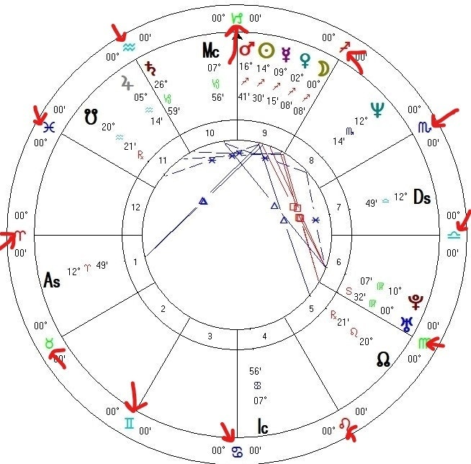](https://media1-production-mightynetworks.imgix.net/asset/9229774/Signs_annoted_on_chart.jpg?ixlib=rails-0.3.0&fm=jpg&q=75&auto=format)

 Taking a look at any natal chart, we see that they have all twelve signs on them. This means that **we are all a unique combination of all twelve signs of the zodiac**. Most of us know at least a little bit about the sign our Sun is in so that leaves only eleven other signs to become familiar with!

Watch this short video for a brief introduction to all the signs.

Signs answer the question “How?”

How does each part of yourself (Planet) go about doing its job?

Aries = with courage

Taurus = with persistence

Gemini = with knowledge

Cancer = with sensitivity

Leo = with confidence

Virgo = with discrimination

Libra = with balance

Scorpio = with intensity

Sagittarius = with humor

Capricorn = with discipline

Aquarius = with originality

Pisces = with imagination

[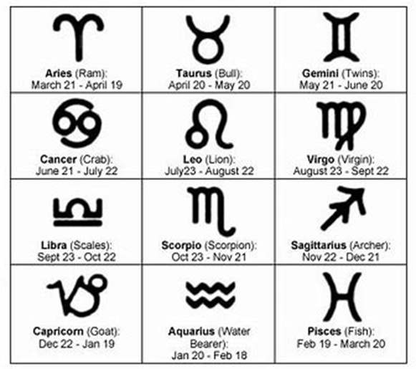](https://media1-production-mightynetworks.imgix.net/asset/9232231/1584658912662.png?ixlib=rails-0.3.0&fm=jpg&q=75&auto=format)