**The Ascendant**

[](https://media1-production-mightynetworks.imgix.net/asset/10913570/Dawn.png?ixlib=rails-0.3.0&fm=jpg&q=75&auto=format)

The Ascendant is perhaps the most important point in your chart, marking the sign of the zodiac which was rising over the horizon at the moment of your birth. This sign is placed over the first house of your natal chart and determines which sign (laid out in sequential astrological order) each of the remaining houses will be ruled by or "Where" (the house) each "How" (the Sign) will fall.  If your Ascendant sign is Cancer, your first house will be in Cancer, your second house is in Leo, then Virgo, etc. If your Ascendant sign is Scorpio, your second house is in Sagittarius, third in Capricorn, etc.

Taking this a step further, the Ascendant determines which planet becomes your Chart Lord - or the planet that represents *you* and has the most impact over you throughout your time here in Earth School. To find which planet is your Chart Lord, simply look up which planet is the ruler of the sign that your Ascendant is in.

So, if your Ascendant is in Cancer, your Chart Lord is the Moon, if your ASC is in Libra, your planet is Venus, etc. Pay particular attention to anything your chart ruling planet is doing in the sky currently such as is it retrograde? changing signs? what phase it is in (for the Moon) as you may feel these changes more strongly than someone with a different Chart Lord.

Here is a handy list of rulerships for you:

[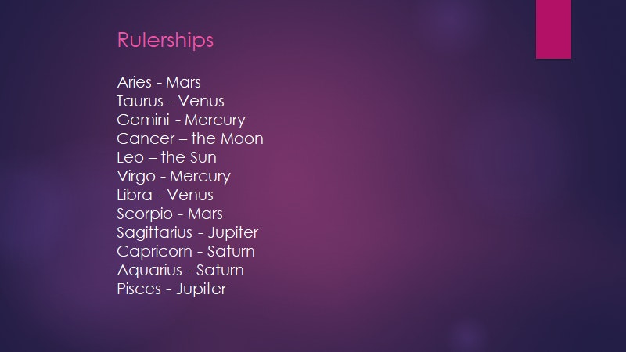](https://media1-production-mightynetworks.imgix.net/asset/10914396/1589662880960.png?ixlib=rails-0.3.0&fm=jpg&q=75&auto=format)