**Synthesis**

[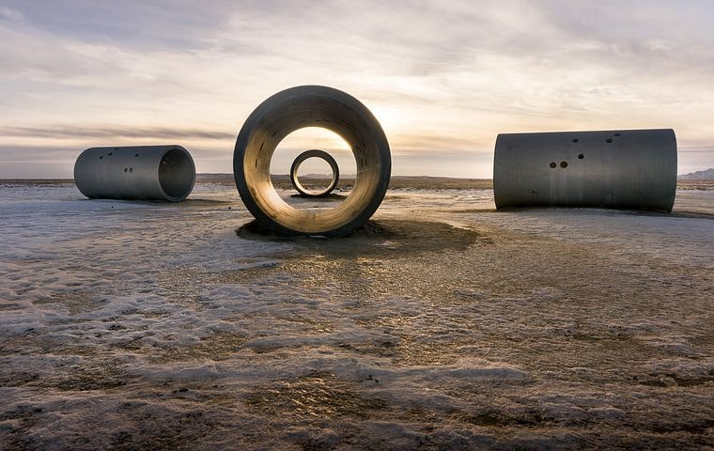](https://media1-production-mightynetworks.imgix.net/asset/10101786/sun-tunnels-2750805__480.jpg?ixlib=rails-0.3.0&fm=jpg&q=75&auto=format)

We have been digging deeper into the meanings behind the signs of the zodiac. Knowing the element and modality of a sign opens up the possibility for a truly robust understanding of that sign's potential and challenges. For example, Leo is a fire sign (independent, energetic, enthusiastic, impulsive, selfish) and a Fixed sign (stable, loyal, steadfast, and predictable.) So, a Leo might be described as "predictably enthusiastic", "energetically loyal", etc. Sagittarius is another fire sign so we still have the fire element words but this time we are looking at mutable energy (versatile, adaptable, unpredictable, easily bored.) A Sagittarius is "*un*predictably enthusiastic", "energetically versatile", etc.

In this video we will take a further look at elements and modalities and how we can combine them for richer understanding.

Here are some words for the modalities:

Cardinal: leadership, assertiveness, action, vigor, starters, change makers

Fixed: stability, loyalty, predictability, status quo, stubborn, steadfast

Mutable: versatility, adaptability, unpredictable, in flux, letting go

And here is a wonderful way to understand the elements from astrologer Kelly Surtees:  "You need passion and action (Fire) to motivate and inspire you; practicality (Earth) to keep you grounded; logic and intellect (Air) to provide you with information and facts; and emotions (Water) to help you connect."