**Sect**

[](https://media1-production-mightynetworks.imgix.net/asset/11416959/SunMoon.jpg?ixlib=rails-0.3.0&fm=jpg&q=75&auto=format)

Most astrologers define the natal chart as "a snapshot of the sky at the moment you were born." Whilst this is completely true, it does not fully describe the natal chart's dual purpose as both a sky map and a kind of sky clock. Try thinking of the wheel as both a representation of the sky, both above and below the horizon, and as a 24-hour clock face on the day you were born.  Once we superimpose the planets onto this map/clock, based on the exact moment of your birth, we can tell at a glance whether you were born in the daytime or the nighttime.

Knowing whether you were born when the Sun was visible (above the horizon) or not visible (below the horizon) is one of the keys to traditional astrology. This simple technique determines whether you belong to "Team Day" with the Sun as your Team Captain or "Team Night" with the Moon as your Team Captain.

Team Day is typically more interested in interacting with the outer world in a more objective way. Team Night is more private and subjective.

Very simply: If your Sun was above the horizon at the moment you were born, you are Team Sun (Sun). If your Sun was below the horizon at the moment you were born, you are Team Night (Moon).

[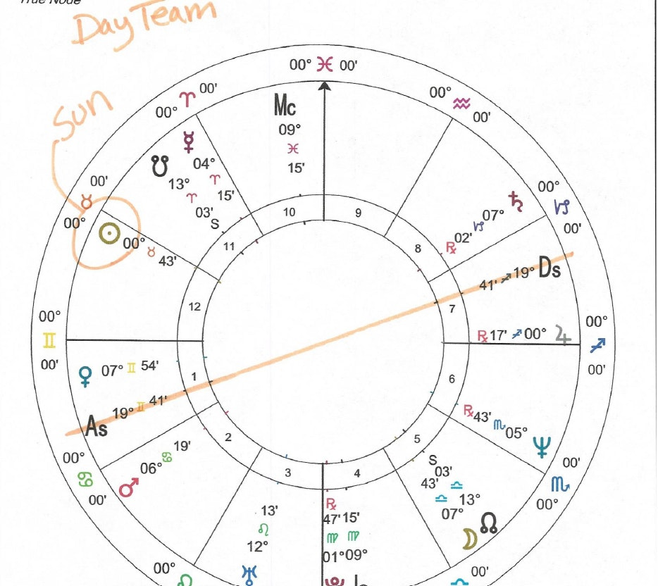](https://media1-production-mightynetworks.imgix.net/asset/11419069/1591221786066.png?ixlib=rails-0.3.0&fm=jpg&q=75&auto=format)

The image below illustrates a Day Chart.

And the image below illustrates a Night Chart.

[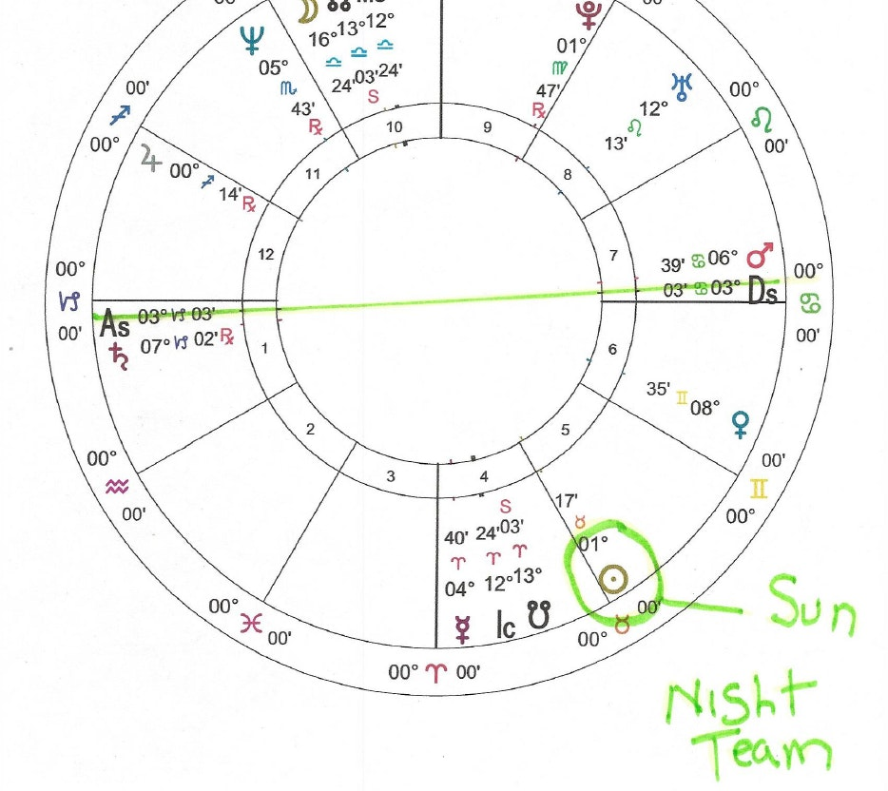](https://media1-production-mightynetworks.imgix.net/asset/11419236/1591222179305.png?ixlib=rails-0.3.0&fm=jpg&q=75&auto=format)

Are you Team Day or Team Night?