[](https://media1-production-mightynetworks.imgix.net/asset/9422539/1585246656964.png?ixlib=rails-0.3.0&fm=jpg&q=75&auto=format)**Putting it All Together**

We have now covered the the basic building blocks of astrology: planets, signs and houses. Although what we have covered may seem like a lot of information, it actually represents about the first week of kindergarten in terms of the information needed for true astrological interpretation. Nevertheless, we can begin to play with the kinds of sentences that will eventually compose our star stories.

 So let's have a little fun!

Below is a compilation of the three basic sets of information we have covered so far.

[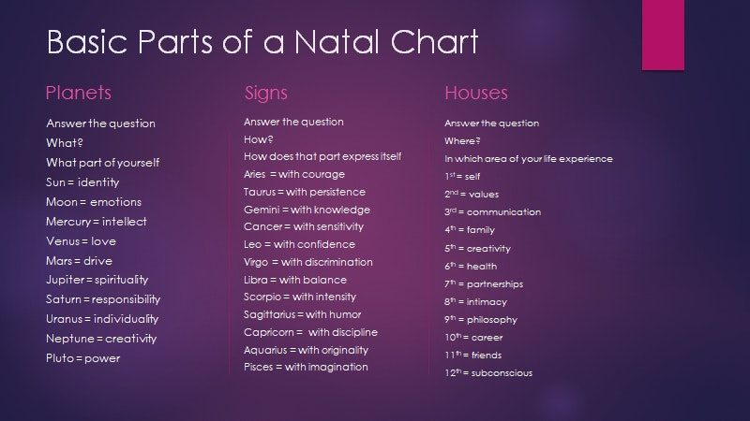](https://media1-production-mightynetworks.imgix.net/asset/9422385/1585246364058.png?ixlib=rails-0.3.0&fm=jpg&q=75&auto=format)

And here are 2 different versions of a form for you to play with. The first is a fill-able form that you can open it and fill it in on your computer or smart phone. The second file is a version that you can print out and fill in by hand if you prefer.

[**Putting it All Together Fillable Form.docx**](https://media2-production.mightynetworks.com/asset/9423709/Putting_it_All_Together_Fillable_Form.docx)

[**Putting it All Together Print Form.docx**](https://media2-production.mightynetworks.com/asset/9423724/Putting_it_All_Together_Print_Form.docx)

You will need **your natal chart**, the **Basic Parts of a Natal Chart**(above), and one of the versions of the **Putting it All Together**(also above) documents for this exercise.

Watch the accompanying video for a quick "how to".