**Moon Phases**

[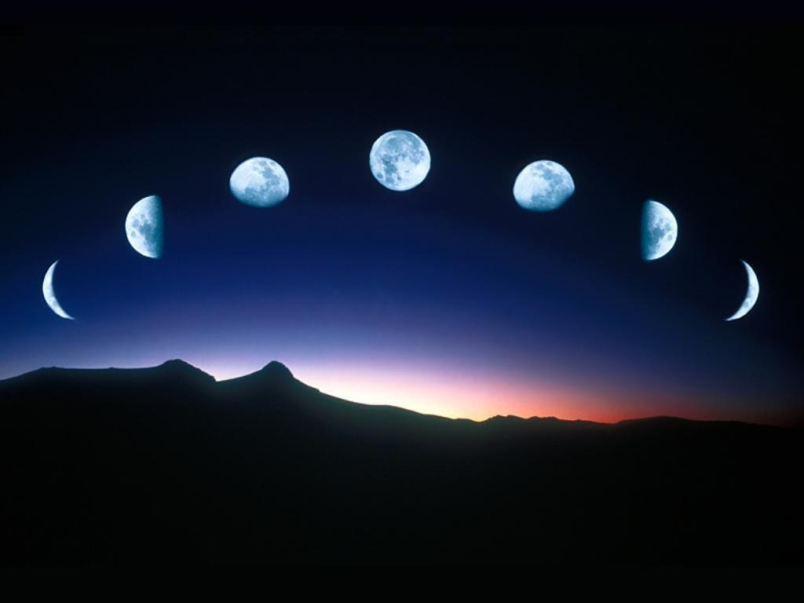](https://media1-production-mightynetworks.imgix.net/asset/13179687/347297.jpg?ixlib=rails-0.3.0&fm=jpg&q=75&auto=format)

Because it affects our body, our emotions, our moods, and much, much more, the Moon is arguably the most powerfully felt influence in our charts. We have looked at the Moon as described by sign and house in our charts, now let's talk about her phases.

Although there are lots of ways to divide the full circuit of the Moon's path, most astrologers use the following eight phases:

New (0°- 44°) beginnings, the seed, naivete

Waxing Crescent (45°- 89°) birth, the sprout, hunger, hope

First Quarter (90° - 134°) Action, drive, group causes, justice

Waxing Gibbous (135° - 179°) improvement, service, teamwork

Full (180° - 224°) peak, spotlight, drama, involvement

Waning Gibbous/Disseminating (225° - 269°) teaching, sharing, wisdom

Third Quarter (270°- 314°) authenticity, longing, sweet sorrow

Waning Crescent/Balsamic (315° - 359°) the dark, release, endings

There are several ways to find which phase of the moon you were born under but they are all based on the New Moon (when the Sun and the Moon are in the same degree in the sky) as the starting point. Unless you were born under the New Moon, the Sun and Moon will be in different areas of your chart though. So, we start at the Sun (where the Moon was during the New Moon) and count the number of degrees ahead of the Sun the Moon is at now. Remember that all the planets are moving counter-clockwise!