**Aspects II**

[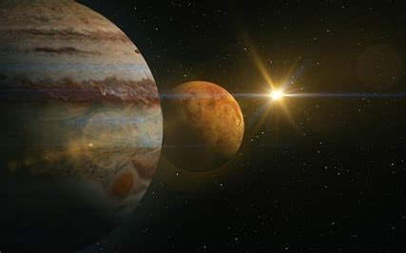](https://media1-production-mightynetworks.imgix.net/asset/16051958/1604871644888.png?ixlib=rails-0.3.0&fm=jpg&q=75&auto=format)

Now that we know how to identify an aspect, let's look at what each of these aspects mean. In a nutshell - an aspect describes the nature of the relationship between the two or more planets involved or how they "get along" with each other. Here is a handy key to these relationships:

**Conjunction** -  Key Word: **Bonded**

Two or more energies that sit next to each other in the chart. This is the most powerful aspect. Whether it is challenging or harmonious depends largely on the nature of the planets involved.

**Sextile** - Key Word: **Energizing**

Two energies that naturally stimulate and energize each other, creating mutual interest and excitement.

Potential Shadow: Aid and abet each other; run automatically.

**Square**- Key Word:  **Conflict**

Two energies at odds with each other's reality. Integration requires an acceptance of differences that exceeds understanding.  Offers greatest challenge and greatest opportunity for evolution.

**Trine** - Key Word:  **Support**

Two energies that are in rapport, creating ease and flow between them.  Natural talent.

Potential Shadow: Can be lazy, unconscious. Taking talent for granted.

**Opposition** - Key Word:  **Tension**

Two energies that create a polarity in the chart. Unintegrated, represents a source of tension. With understanding of each other’s value, creates complementarity.

So, first, it is important to know the natures of the planets involved. For example, Venus and Jupiter are happy, helpful, benefic planets whilst Saturn and Mars are challenging, triggering, malefic planets.

Then we start to see what it would be like to have two happy planets in a conjunction versus two challenging planets. Or how about a happy planet and a challenging planet in an opposition? Or two challenging planets in a square? Play around with this and let me know what you find!