**What is the Natal Chart?**

Imagine the moment you were born: just you and the vast expanse of space (the Universe type of "space"). No hospital, no back seat of a taxi, no birthing pool - no mom or doctors - no Earth or Kansas or Timbuktu - just the two of you. This is the basis of the Natal or Birth Chart in astrology. You, as the center of your universe.

[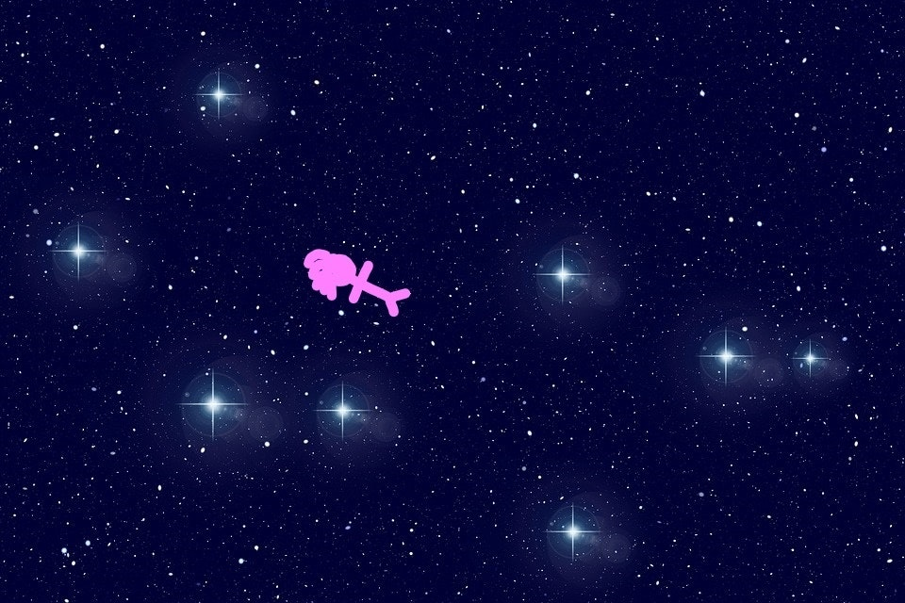](https://media1-production-mightynetworks.imgix.net/asset/8720234/Universe_with_infant.jpg?ixlib=rails-0.3.0&fm=jpg&q=75&auto=format)

Super cosmic. Super woo-woo. Super crowded and confusing. Ancient Babylonian, Egyptian, and Greek astronomers thought so anyway. As they contemplated the chaos, they began to find patterns amongst the stars, recording them and naming many of them. Twelve of these patterns or constellations became the basis for the twelve zodiac signs as we know them -Aries, Taurus, Gemini, Cancer, Leo, Virgo, Libra, Scorpio, Sagittarius, Capricorn, Aquarius, and Pisces - which were laid out in a wide belt encircling the Earth. This belt seemed to rotate throughout the day with one constellation rising above the horizon every two hours.

[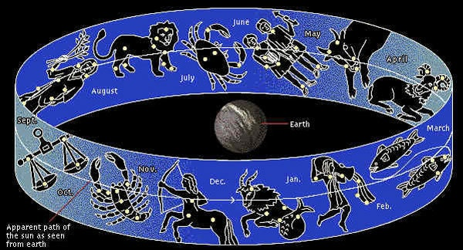](https://media1-production-mightynetworks.imgix.net/asset/8720407/Zodiac_Belt_2.jpg?ixlib=rails-0.3.0&fm=jpg&q=75&auto=format)

Against this fixed backdrop, all events on Earth - from the birth of nations to the birth of little star children - could now be pin-pointed and studied. All these stargazers needed was a portable means of recording these events: the Natal Chart or Wheel was born.

[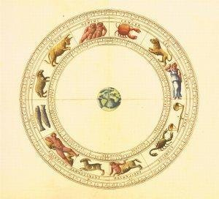](https://media1-production-mightynetworks.imgix.net/asset/8720582/135759-300x272-Zodiac_wheel1.jpg?ixlib=rails-0.3.0&fm=jpg&q=75&auto=format)

 Although the natal chart has evolved and often now includes heavenly bodies invisible to the ancients (think Uranus, Neptune, Pluto, and dozens or even hundreds of asteroids) it is still based on the same basic concept: you, as the center of your own universe as defined by the zodiacal belt and the planets in our local solar system.

Here's a little video to pull this together for you: